

PR-NO SAP COUNTRIES, ITEMS UC

Release Note

www.projectobjects.com

support@projectobjects.com

Table of Contents

Overview: 3

Unit of Measures Page for ITEMs UC: 3

User control for ITEMS in pr-no sap countries form: 4

Creation of records in ITEMs UC: 5

Export to excel and full-screen functionality: 6

Real-time column filtering in PR-NO sap countriesies form: 7

## 

## Overview:

In this release, we have developed the new user control **ITEMS**. Our objective is to manage Items in a dedicated Tab in the “**PR- No SAP Countries**” Form. We are also using data created in the **Unit of Measures** page in standard code in **ITEMS UC**. We have also implemented **Real-Time Filtering** in the **ITEMS UC**.

## Unit of Measures Page for ITEMs UC:

Here in ITEMS UC, we have created the drop-down for the **Units of Measures** column. Data in this drop-down is bonded from the **Unit of Measure** page of standard code. This page is customizable for the end-users.

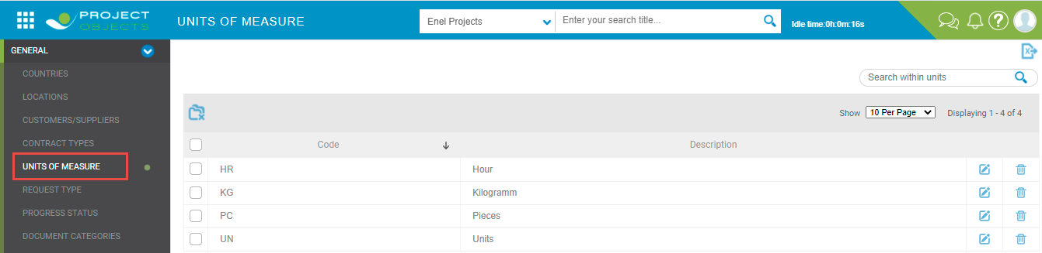

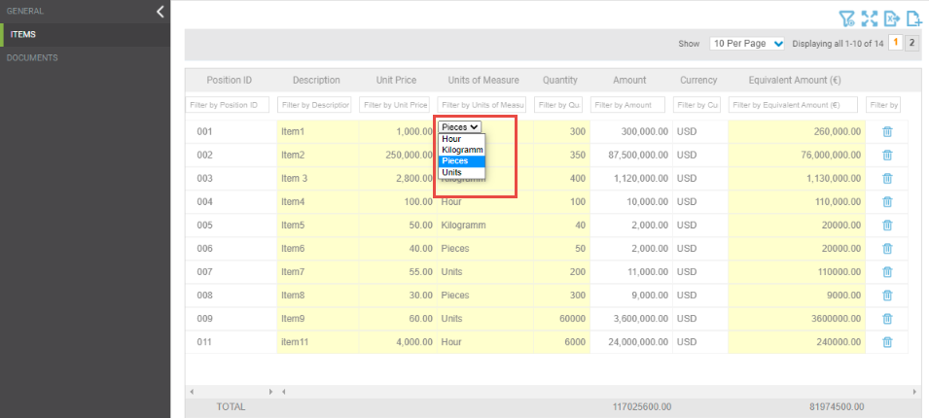

## User control for ITEMS in pr-no sap countries form:

Here we have developed a new user control for **“ITEMS”** which is used in the **PR- No SAP Countries** form. This User control is a grid with 8 columns.

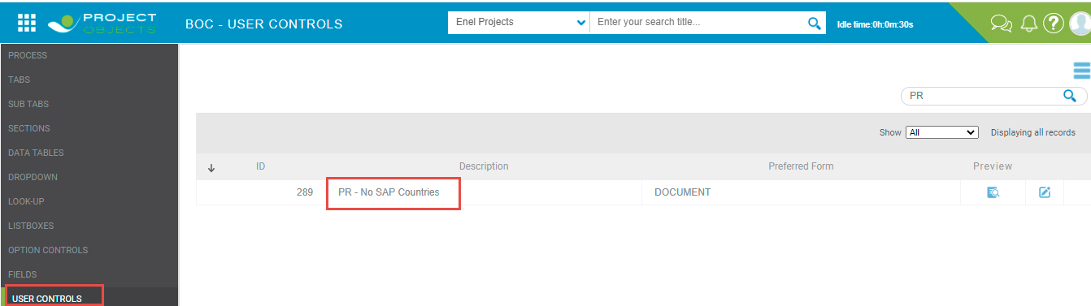

This user control is placed in the **PR- No SAP Countries** form after the **“GENERAL”** tab. This user control contains 8 columns in the order defined below:

Position ID> Descriptions > Unit Price > Unit of Measures > Quantity > Amount > Currency > Equivalent Amount €

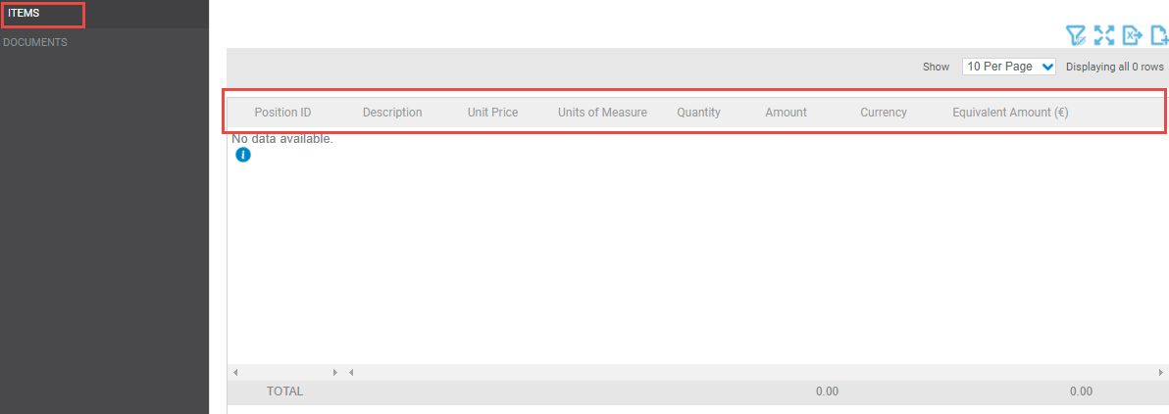

We have implemented the following data logic for the above 8 columns if the record is created in the ITEMS UC:

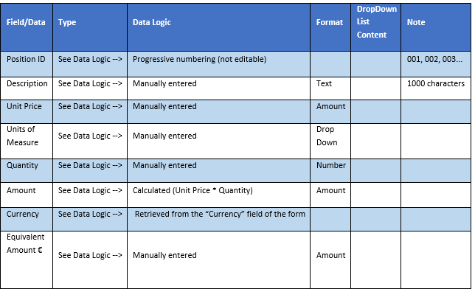

## Creation of records in ITEMs UC:

Users can create records manually in **ITEMS** UC.

* If a user wants to create a record or add an item, we have implemented a **“add new”** icon on the top right corner of the grid. A new record will be added on click and the user can fill in the details and save the record.

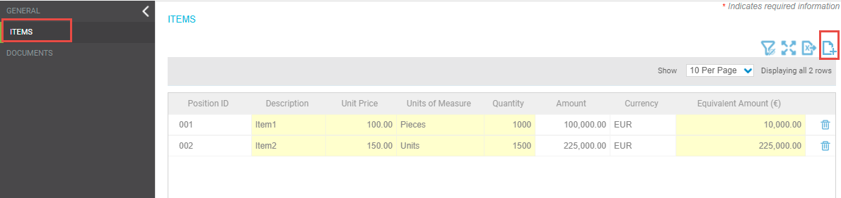

* Here users can add more than 100 records in ITEMS UC.
* We have also implemented the EDIT/DELETE functionality in ITEMS UC. Here user can add/ edit/ delete the items as per the requirements.
* We have also implemented a footer row, which shows the TOTAL ( sum of the amount of all items and sum of the equivalent amount of all items).
* We have also implemented the paging functionality in ITEMS UC. If the number of records is high then the user can use paging to view the records.

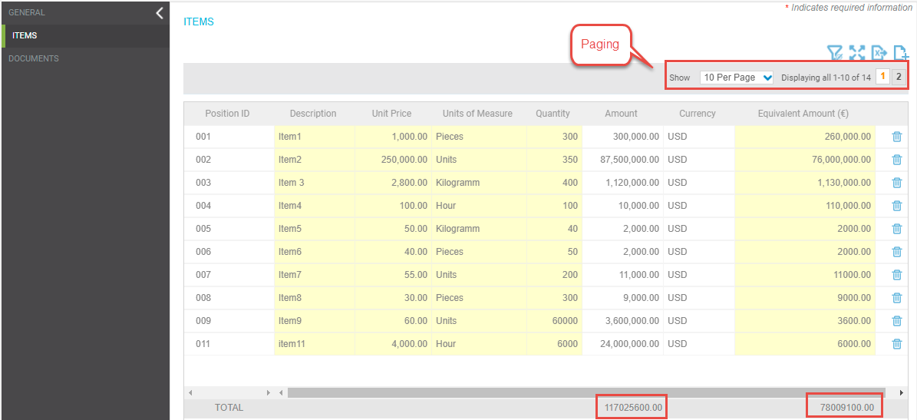

## Export to excel and full-screen functionality:

* Here we have also implemented the Zoom-in, Zoom-out functionality. The **“Zoom-in”** icon is implemented on the top of the grid. On click, the grid will be visible in full-screen mode.

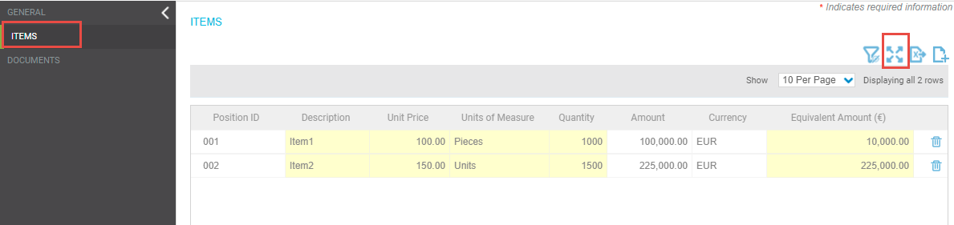

* Here we have also implemented the Export to Excel functionality. The **“Export to Excel”** icon is implemented on the top of the grid. On click, excel will be downloaded with all the created records.

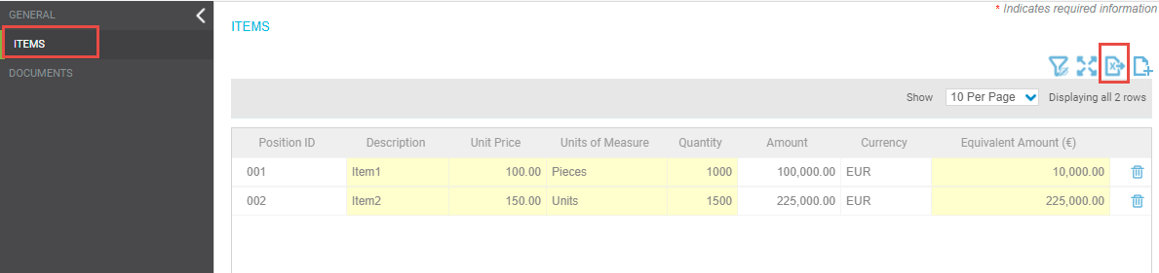

## Real-time column filtering in PR-NO sap COUNTRies Form:

Here we have implemented **real-time column filtering in ITEMS UC**. To enable real-time filtering, a **row-filter** icon is placed on the top of the grid. Real-time filters will be enabled on the clicked row filters icon and the user can filter the column data in the **ITEM UC** grid.

